**ONLINE TICKET BOOKING SYSTEM**

Online movie ticket booking system is a web-based portal where you can book tickets in advance, know your movie timings, watch trailers and read synopsis.

You get to know everything about a film, its ratings and show time simply sitting on your lounge chair. What you have to do is simply go to our web portal for **Online Movie Ticket Booking System**, register yourself and access all the movies and theaters and various other highlights. On our portal you can also buy tickets on the second go (tickets bought previously by another user and put up for resale) and save your money.

Online Movie Ticketing System in PHP is a user-friendly project and can be accessed from anywhere. There is no need to go to the theaters and wait to book your tickets and return empty handed if the tickets are unavailable. You can simply track everything about a film just by clicking on it.

You can buy tickets just by choosing a movie and show timings. Also, there are three classes for a movie theater. You can pick from Platinum, Gold, or Silver class to buy tickets.

**In this portal, there will be two types of users:-**

1. The Visitors or the registered users  
2. The Administrator (who is responsible for updating the portal)

**ROLE:**

**Visitor or Registered user:**

The visitor first needs to register on the portal to avail the booking services. The visitor can enjoy watching the trailers of a particular movie. He or she can select show time and date, and book the tickets opting from one of the three classes according to their preference. They can read the synopsis, check the star ratings and read a synopsis of movie on our portal. Special offers are available to women only groups, children aged 3 to 12 years and for the weekends. Movie theaters reviews can also be checked by the users for their convenience. The users can also buy tickets on the second go (that is tickets bought previously by another user and put up for resale). Pre-booking for snacks is also available with special discounts.

**Administrators:**

The administrators are the backbone of this portal. They are responsible for all the updates and edits on the portal. They will add a new movie or delete an old movie based on the user’s reviews and the release dates. They will also edit the show dates and timings for the movies. Any problem faced by the user will be solved by the administrators. The administrators will have a unique user id and password to allow them to access the part they are supposed to be editing.

**ONLINE MOVIE BOOKING SYSTEM FEATURES:**

1. Sign-in for registered users and sign-up for new users.
2. View show time just by selecting your preferred date.
3. Movie synopsis and star ratings.
4. Movie trailers.
5. Admin dashboard:
6. Add, delete and edit movies.
7. Add, delete and edit shows and their rates for each of the classes.
8. Tickets available on the second go (tickets bought previously by another user and put up for resale).
9. Pre-booking for snacks and special discounts available.
10. FAQ and Contact Us options available for the user’s grievances.

**Homepage**

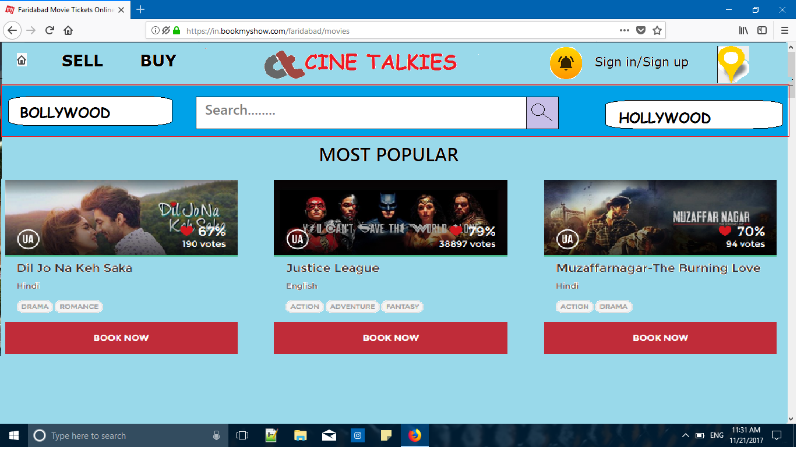

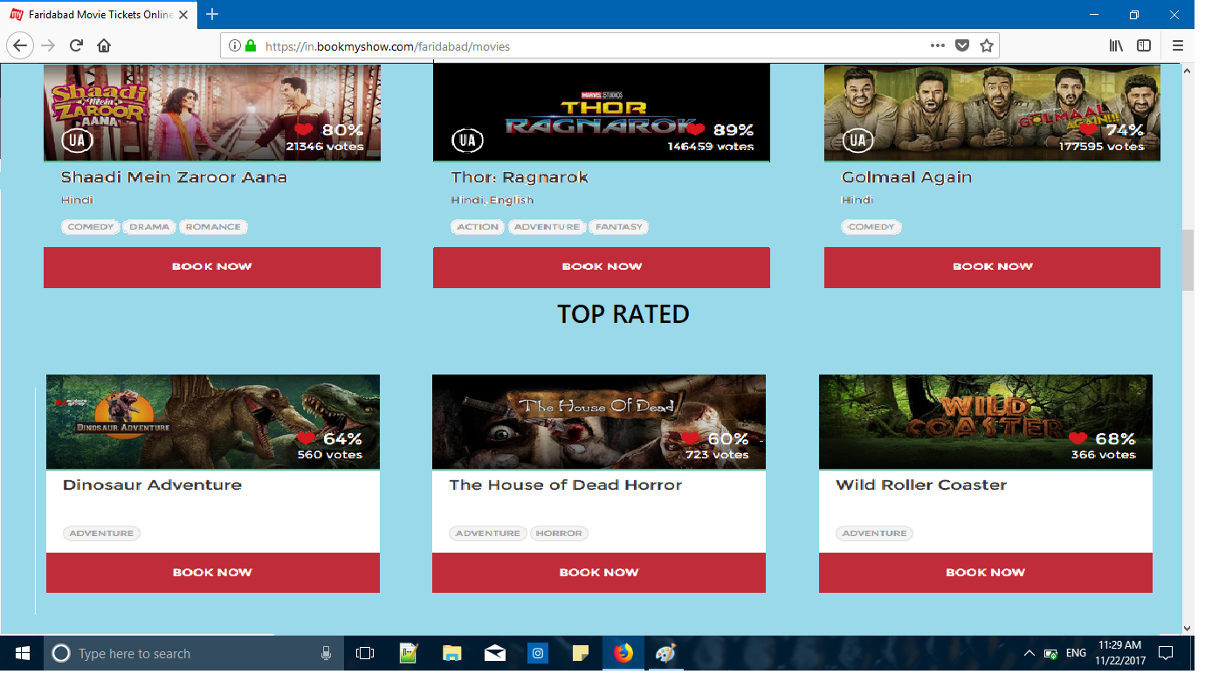

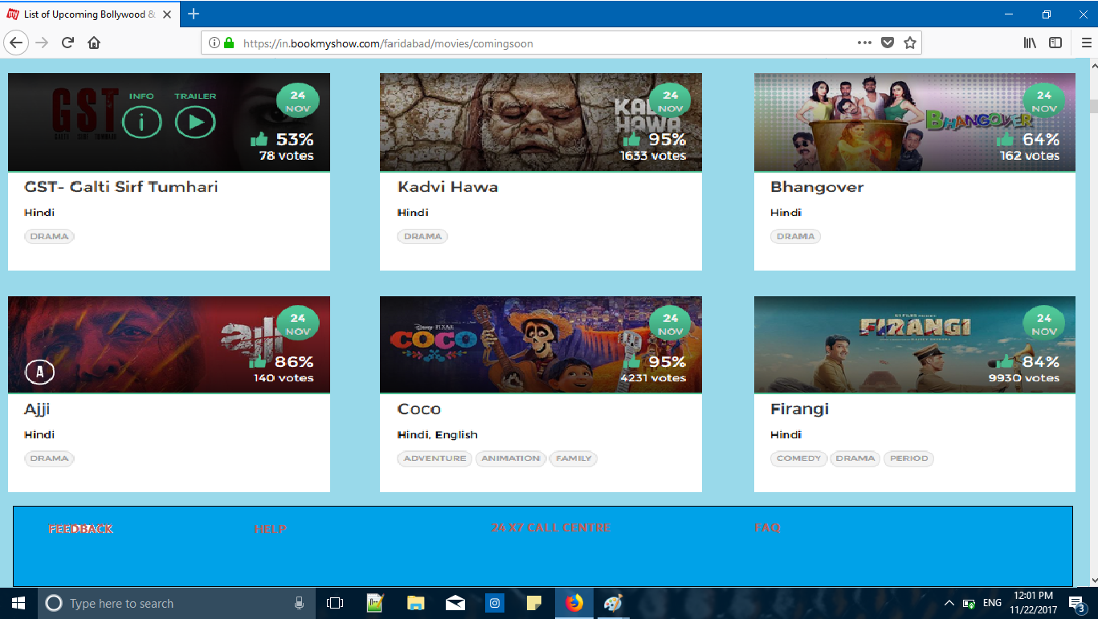

The home page will be consisting of 4 rows where the first row will remain static for every page we jump into.

* **First row**(the static row) – this will be having options as following :-

1. **Home icon** :- As we click on the home icon the user will be directed on home page.
2. **Sell icon** :- if a user clicks on the Icon. The user will be asked to login. If the user is already logged in the sell page will be opened.
3. **Buy icon** :- As a user clicks on this icon The user will be asked to login

.if the user is already logged in the

sell page will be opened.

1. **Website’s icon** :- this is a static Icon which shows the icon of the

Website.

1. **Notification icon** :- this icon tells the user about the recent updates and other notifications.
2. **Location icon** :- this icon will be used to set the location of a user.

* **Second row** :-the second row will be having three options as follows:-

1. **Bollywood:-**  As the user clicks on this option the movies will be selectively shown of Bollywood.
2. **Search :-** The search option will be used to search a specific movie,hall.
3. **Hollywood:-**  As the user clicks on this option the movies will be selectively shown of Hollywood.

* **Third row:-**  this row will be having 5 rows and three columns first two rows will be of the most popular, next two rows will be of top rated movies till then, last row will be of the upcoming movies for that month.
* **Fourth row :-**  this row will be having three options as follows:-

1. **Feedback:-**  this option will be used by the user to give any kind of feed back which will be linked to google forms.
2. **Help:**- this option will be used by the user to take assistance if finding any difficulty in any step during a ticket booking.
3. **FAQ:**- this is option will take the user to frequently asked question.

**SIGN IN**

**Facebook Button-** Clicking on it takes the user to the sign in page of Facebook so that, the users can use their Facebook accounts to log into our website.

**Google Button-** Clicking on it takes the user to the sign in page of Google so that, the users can use their Google accounts to log into our website.

**E-mail Block-**If the user does not have or wish to use his Facebook or Google id he can provide a registered custom id here.

**Password Block-** It is used to provide a password for the custom e-mail id.

**Sign-in Button-** Clicking on the button, the user will be taken to the previously opened page and will be signed-in.

**Forgot Password-** Clicking on this the user will be sent to a page where he can reset his password.

**Sign-up Button-** It will take the user to a new page where he can sign-up if he is a new user.

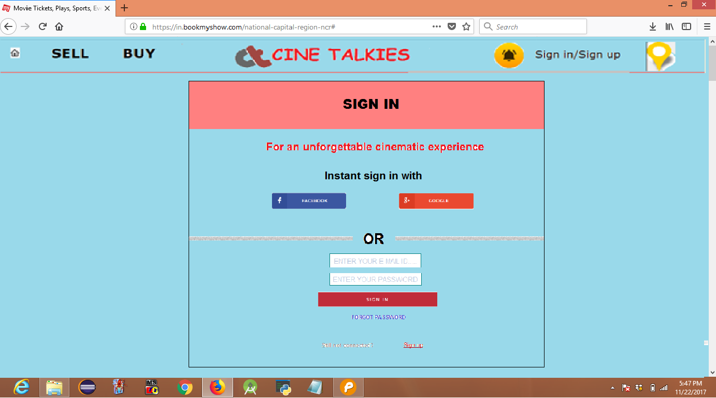

**SIGN UP**

**Facebook Button-** Clicking on it takes the user to the sign in page of Facebook so that, the users can use their Facebook accounts to register on our website.

**Google Button-** Clicking on it takes the user to the sign in page of Google so that, the users can use their Google accounts to register on our website.

**E-mail Block-**If the user does not have or wish to use his Facebook or Google id he can provide a custom id to register.

**Password Block-** It is used to provide a password for the custom e-mail id.

**Confirm Password Block-** The block re-enters password to confirm it.

**Sign-up Button-** Clicking on the button, the user will be taken to a new page and will be asked to sign-in.

**Sign-in Button-** Clicking on the button, the user will be taken to the previously opened page and will be signed-in.

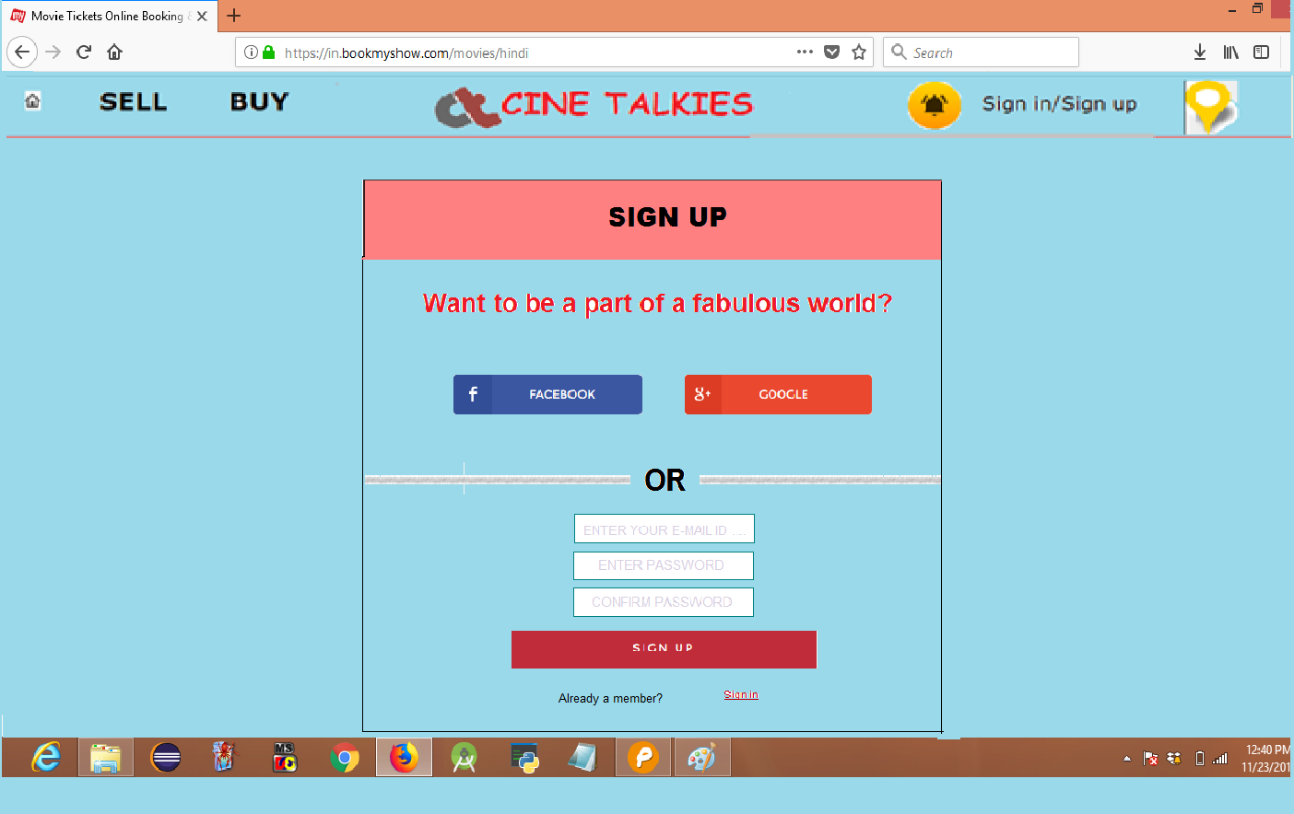

**FORGOT PASSWORD**

**Enter Your E-mail-** Enter the e-mail id where you want the instructions to be sent.

**Send Instructions-** Clicking on this button will send the instructions to your e-mail d.

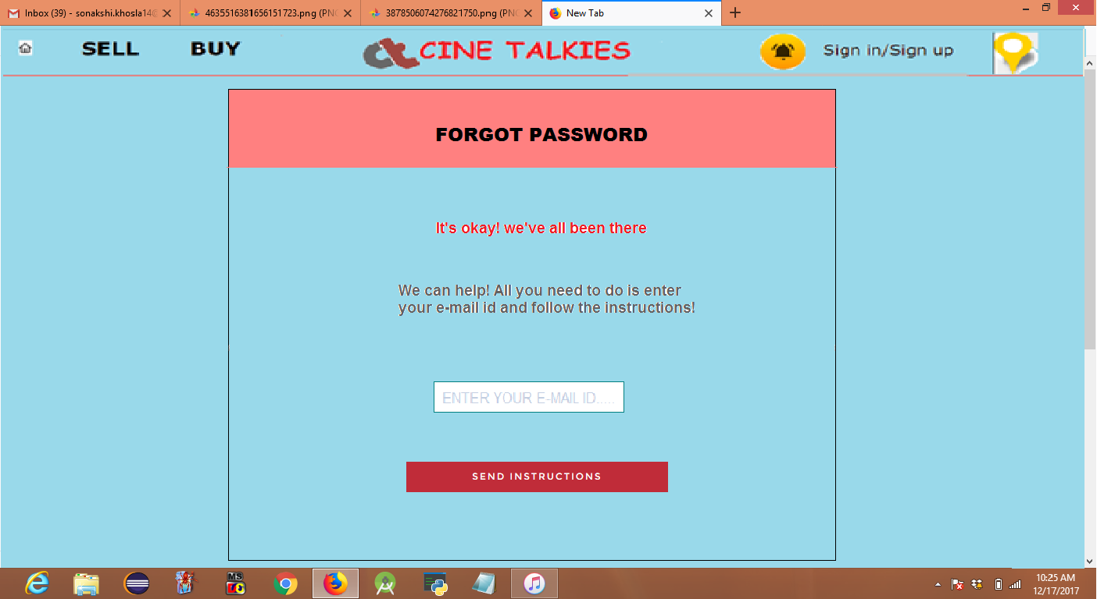

**BOLLYWOOD**

This page shoes the Bollywood movies which are currently running for booking. It has three blocks.

Clicking on the movie we can see its trailer, know its information-ratings, synopsis, timings etc. You can add it to the wishlist by clicking the heart. The tab also gives the genre and the CBFC certification of the movies. Book Now button takes the user to the booking pages.

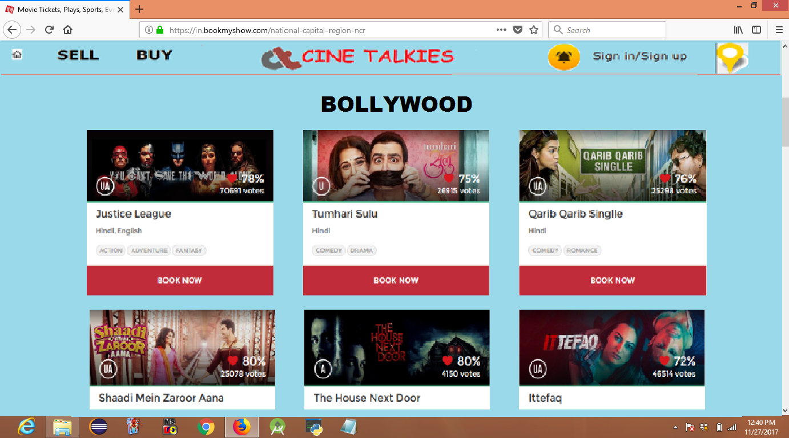

**PAYMENT GATEWAY**

**Use Paytm Wallet-** This checkpoint is selected if the user wants to use the money in his Paytm wallet for payment.

**Saved Details-** If the user’s payment details are already saved, he or she can use them.

**BHIM UPI-** If the user wants to use BHIM UPI for payment; he or she will click here.

**Debit Card-** If the user wants to use Debit Card for payment; he or she will click here.

**Credit Card-** If the user wants to use Credit Card for payment; he or she will click here.

**Net Banking-** If the user wants to use Net Banking for payment; he or she will click here.

**Select from Popular Bank-** This block gives various popular banks to choose from. Some of these are **SBI, HDFC, ICICI bank, Axis bank, PNB** etc.

**Select any other Bank-** This dropdown offers more banks if the user is not registered in the above mentioned bank.

**Pay Now-** Clicking on this button takes the user to the Bank site.

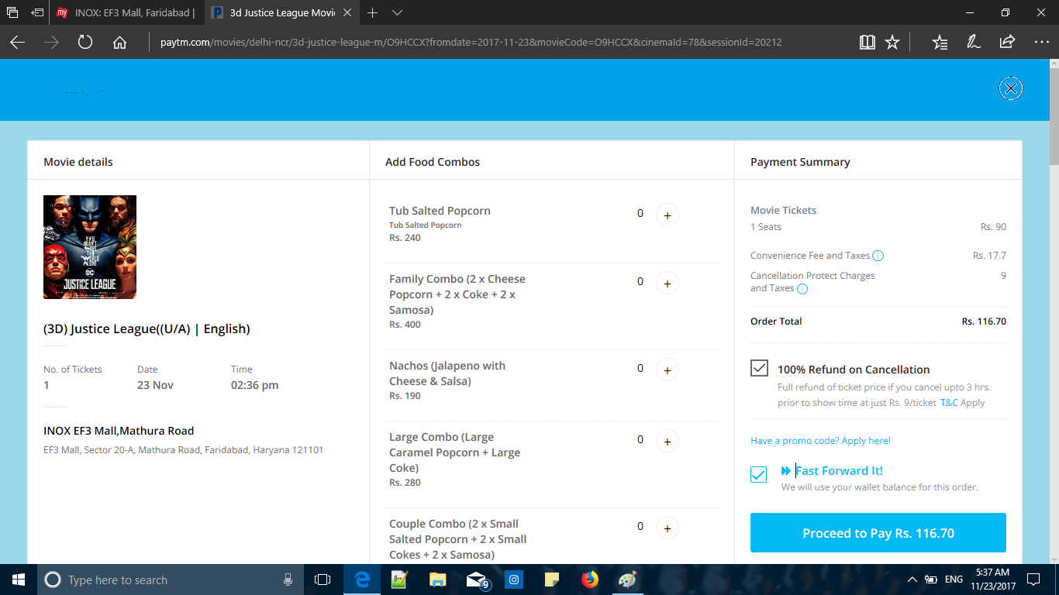**Cancel-** It will cancel the whole process.

Block 8-

There will be three columns divided equally

**first column** will be having the movie details and the icon which will be of 5*5 units the the name of the movie in bold after that we will be having the no. of tickets , with date and the time. Then the location of the mall and the name of the mall.

**column 2**- this row will be divided into n no. of rows where the combos of food will be given.

**Coloumn 3-**this row will represent the payment summary telling the no. of movie tickets and its cost

The convienience fee and the taxes then the total of all

Below that we will have the proceed to pay button. 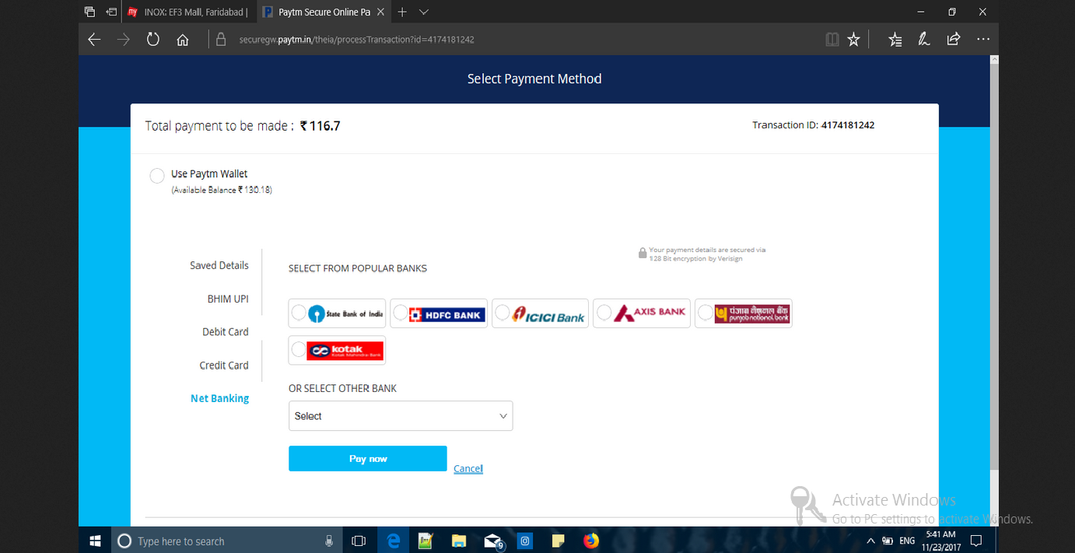

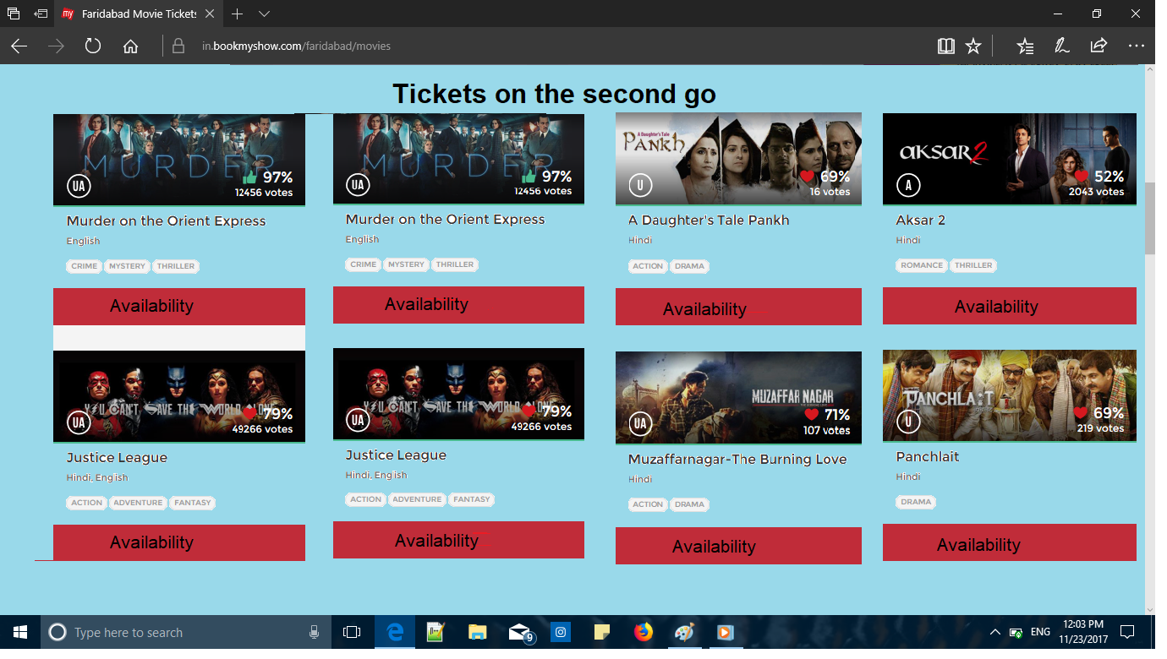**Block of buy**

The page will be having a light blue background

There the pictures available in the users area will be shown according to the location. There will be 4 columns and n no. of rows(depending on the no. of movies there).

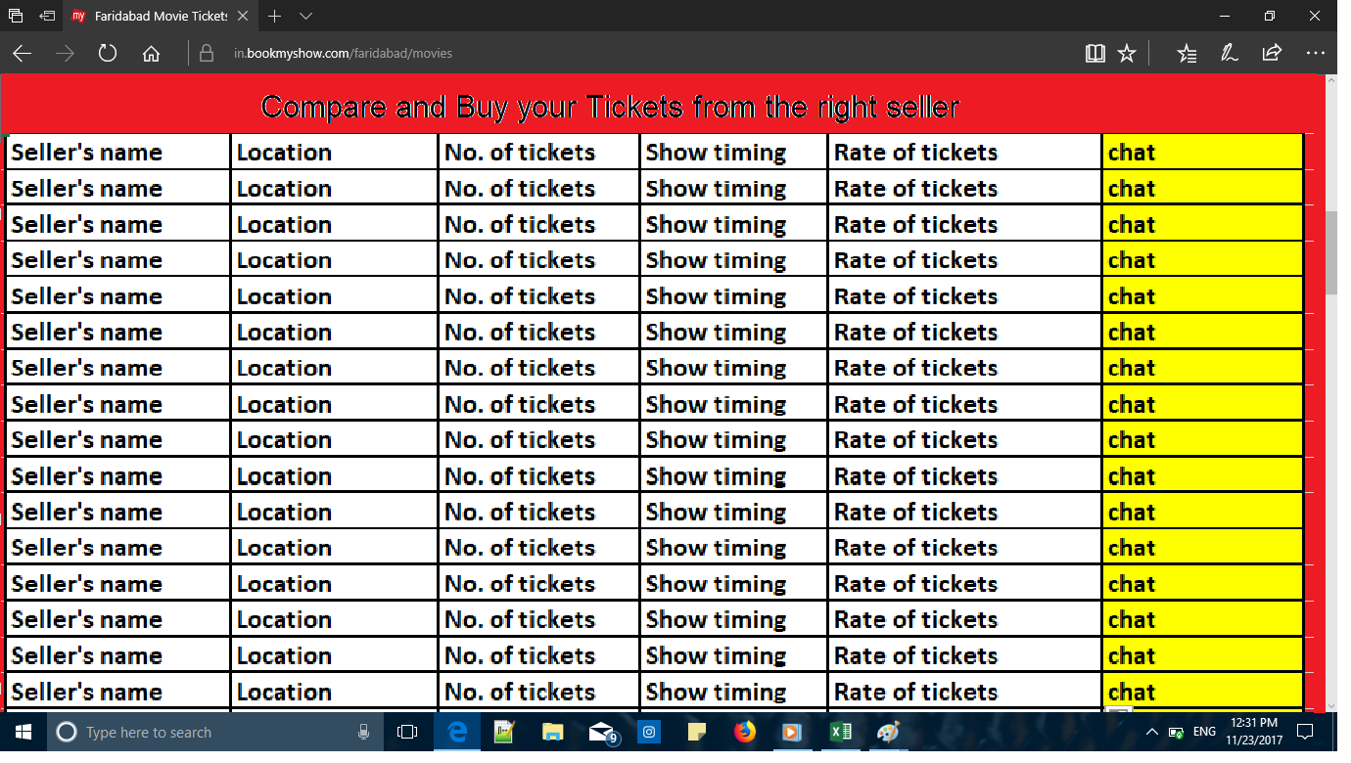

As the user clicks on a specific movie another page opens which has 6 columns and n no. of rows.

First column- showing the seller’s name.

Second column -showing the location of the movie

Third column - showing the no. of tickets available.

Fourth column - this row shows the timing of the specific ticket.

Fifth column - this tells the rate of the tickets which has been set by the seller.

Sixth column - this row shows the option of chat if the buyer likes the rate and all.

**SELLING PAGE**

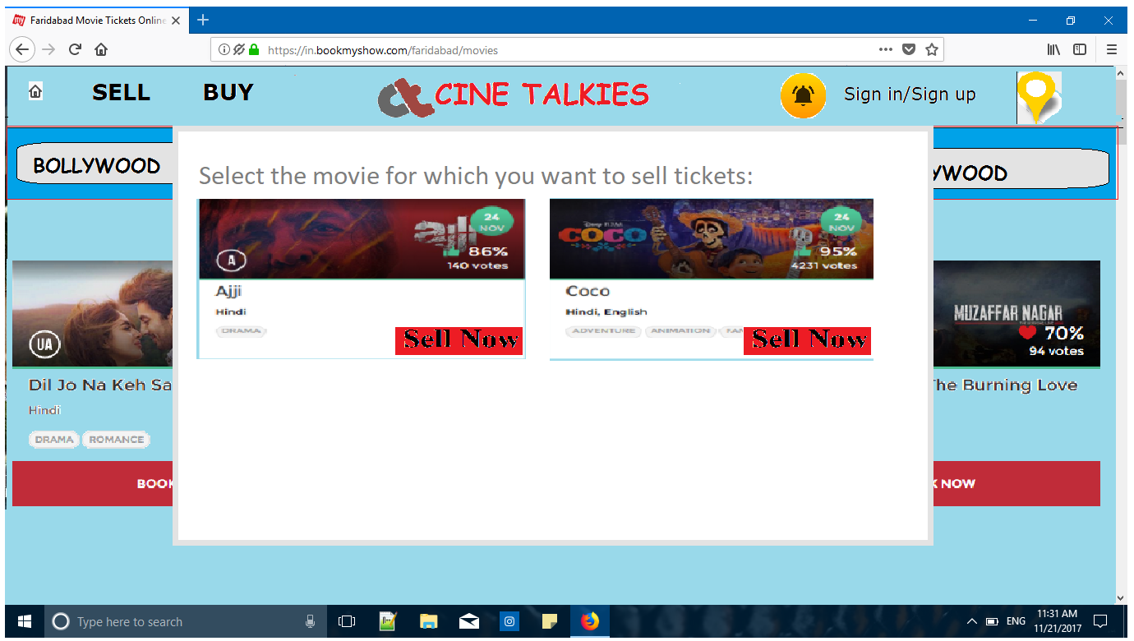

On the **selling home page**

There will be a small pop up window showing the user the Movies which have been bought in the wesite itself

* **Sign in** will enable user to create new account either by doing following any one of the below option.

1. Connect with Google plus.

2. Connect with Facebook.

3. Filling up the sign in form.

* **Sign in** as the option to sell/buy will require their username and password.
* 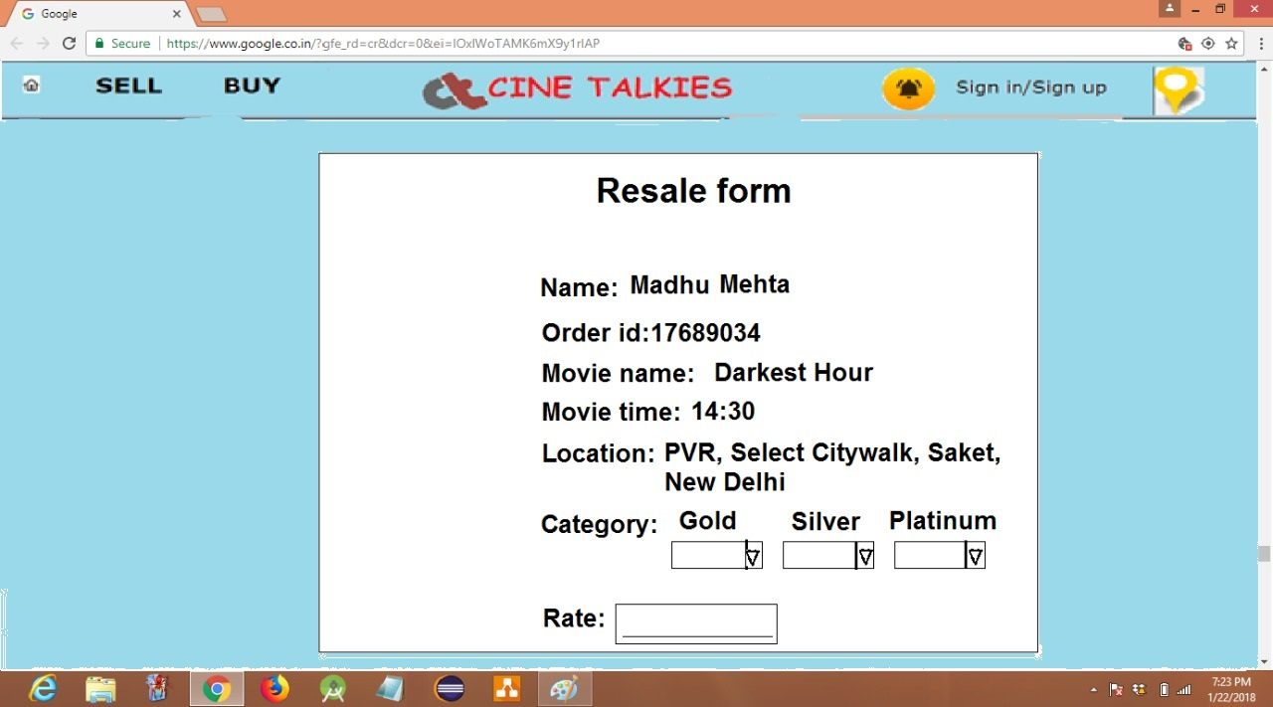

The movie that the user chosen will be in selected category whose information will be asked in adjacent coming up page. The page will have a view profile column in extreme left which will have

* **Display of your profile photo and name**-
* **Option to edit profile**-this will include changing user's user- name, profile picture, or Display name or view the past and recent ads related to the user categorized as sold or selling.
* **Sold** will display past ads (irrespective of successful or unsuccessful deal).
* **Selling** will display the on hold ad(s) given by the seller.
* **Wishlist**-the movies marked with heart are added to wish list with a remainder which update user with its update. User can view their chosen movie or remove them from list.

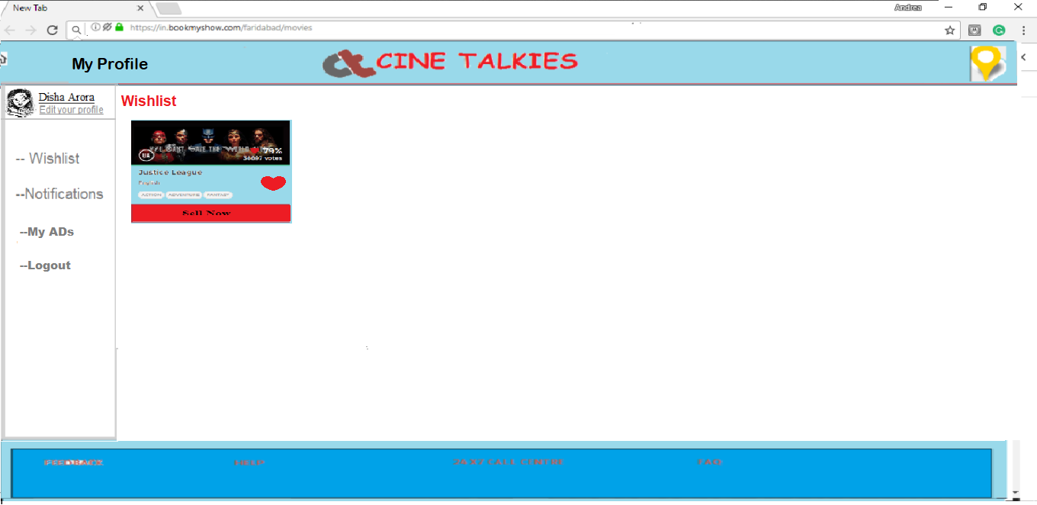

* 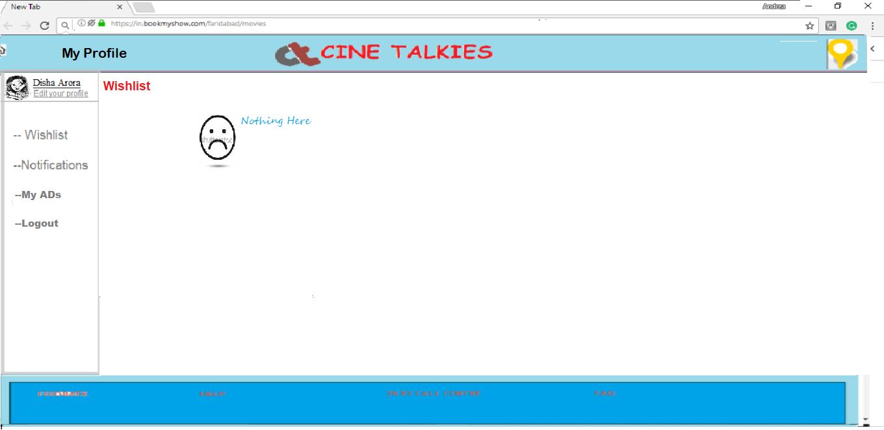**Notifications**-this includes chat marks between buyers and seller with a tabular arrangement of *all, buy* or *sell*.
* **All-** It will give the chats between buyer and seller.
* **Buy-** It will give the chats between user (acting as buyer) and offering a deal to the seller at the other end.

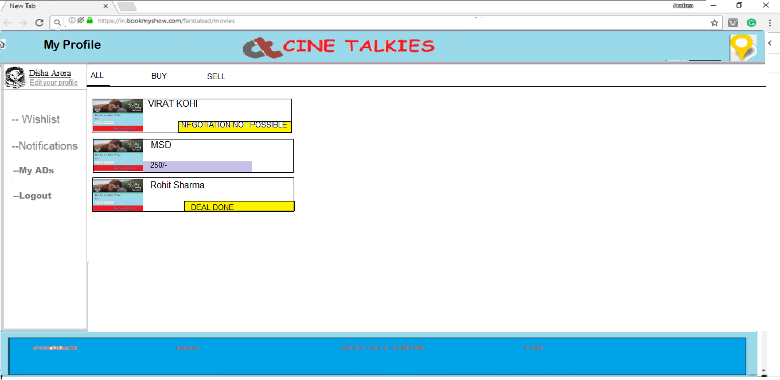

* **Users’ Status-**

1. **REPORT-** if a user feels that the person he/she is chatting with is using offensive or derogatory language, he can report the user to the website.
2. **BLOCK-** if the user does not wish to continue chatting with another person because of some issues, he/she can block him/her, and will not receive any messages from him/her.
3. 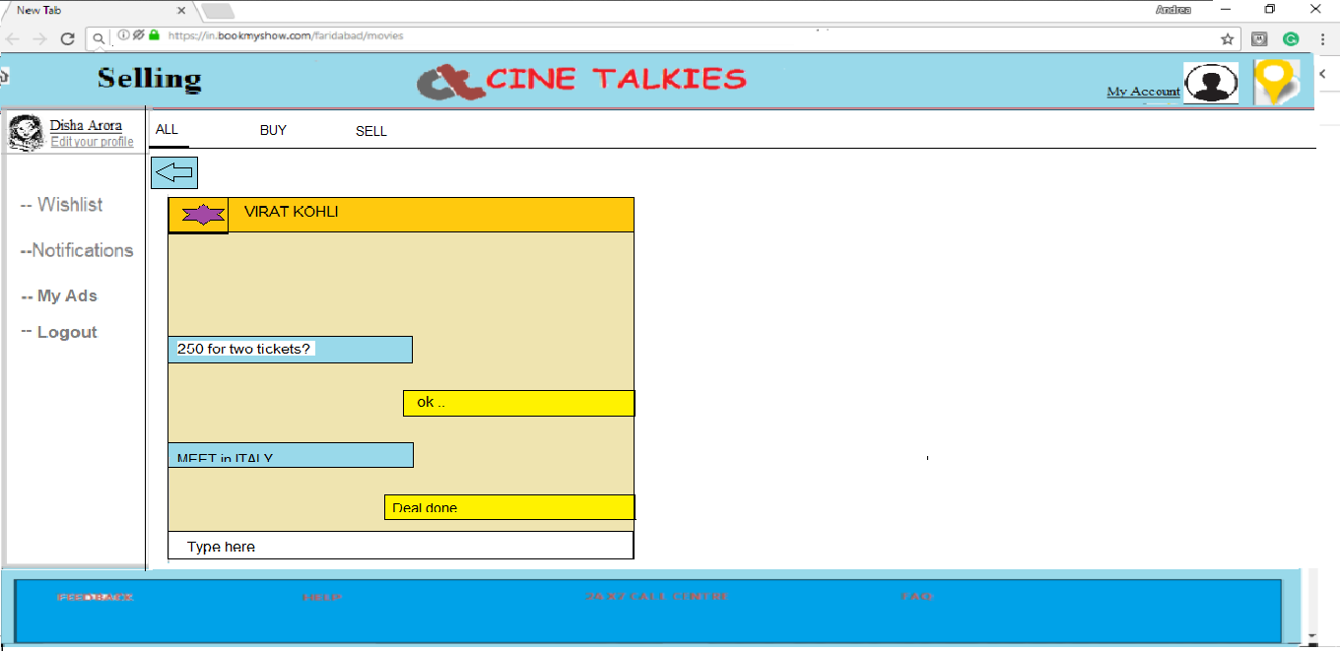**BAN-** if a user is reported by five other users then he will banned from using the website. On logging in he/she will be shown a message, “You have been banned from the website. You can no longer access your access you account.”

* **My ads-** the tickets on sell hold will be in selling column and past sold out will be in sold column.

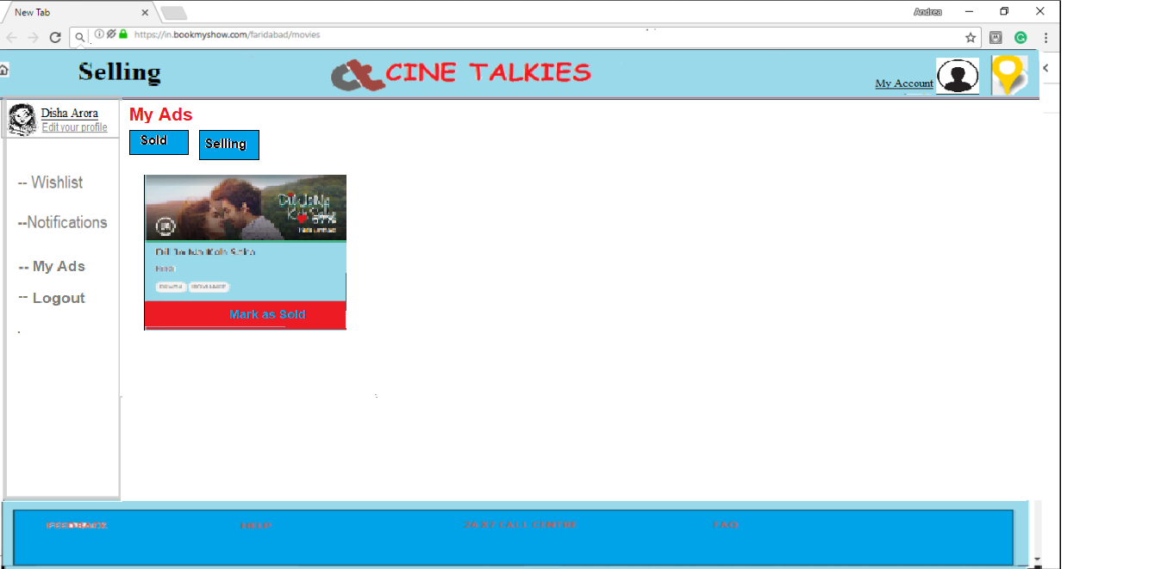

* **Logout** -to exit and close your account.

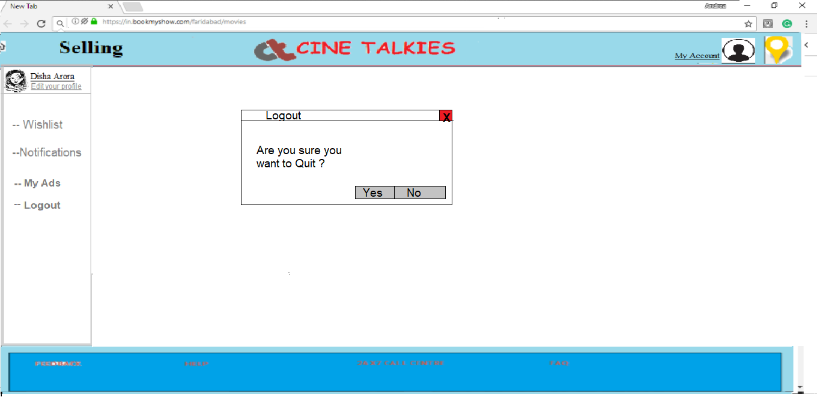

Center of the page will input the date, venue, timings, maximum available tickets, price set by seller, and any other description if seller wants to add.

Once the **submit** button is clicked, the ad will be added to sell category mentioned earlier in *my ads* column and will display in the *buyer's window.*

If any of the buyers is interested, he will start having conversation through the chat option.

He will enter a page where user can see the zoomed out view of all his chats with various people. On clicking any particular chat he can start typing and tell seller the interested price. The seller and buyer can further have chat to negotiate the price and destination confirmed deal will make the ad in sold column to come to my ads.

LOCATION

The location is asked if the user sign ups or if a user wants to change the location.

* **Location Button-** As soon as the user clicks on this button , the user will be taken to a menu containing various states.The user can select a state out of the states or can even search a place provided in the search bar.
* The user is taken to a list of cities in the selected state.
* After the user has selected a city, the user is taken to the home page of the website corresponding to that city.

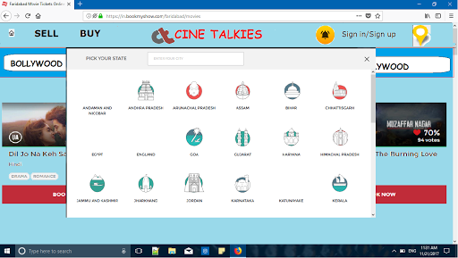

NOTIFICATIONS

* **Notifications Button**-Clicking on the notification button shown by a bell icon , a menu containing different notifications appears.

1. A notification headed by a star notifies the user of the movies releasing soon which the user previously added to their wish list. Clicking on this notification takes the user to their wishlist.
2. A notification headed by a hash appears as soon as the user clicks on the book now button for a movie for which tickets are available on the second go. Clicking on this notification takes the user to the chart where details of the tickets are available put up on resale by different users.
3. A notification headed by a clock notifies the users how much time is left for a movie for which they have booked tickets. Clicking on it will direct the user to the movie details page.

* The number of notifications is visible on the bell icon and disappear as soon as the user clicks the icon.
* At the bottom corner of each notification, how much time has passed since the notification came can be seen.

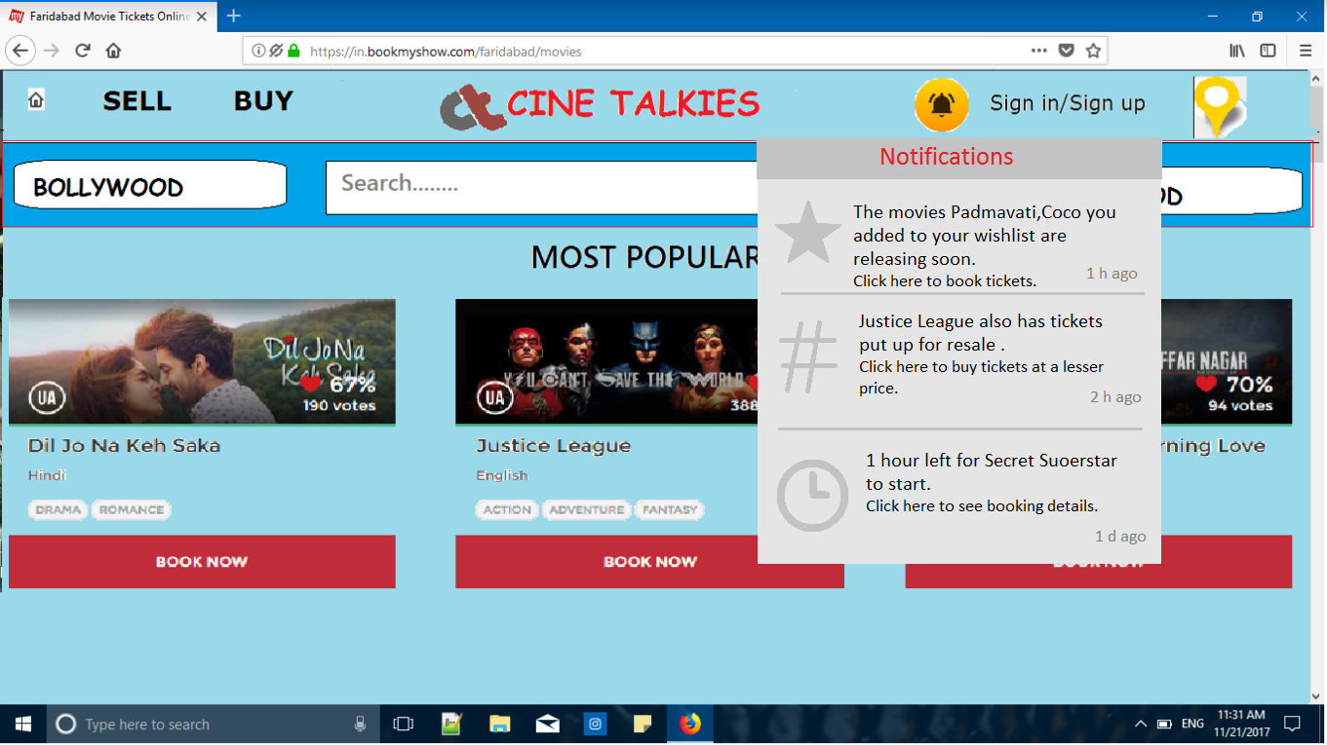

CLASS DIAGRAM

**Generate_order_id()**

